1. All dates in BSON are stored in ISO format and here you can see an example of the Date stored in ISODate format.
2. This is a representation of the date in “**Extended JSON Mongo Shell Mode**”.  
   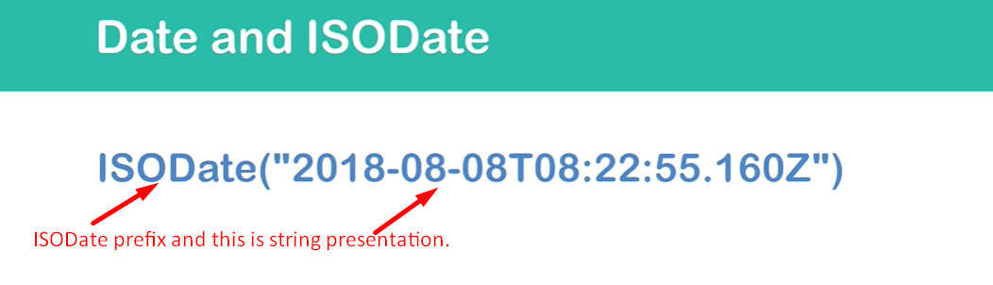
3. 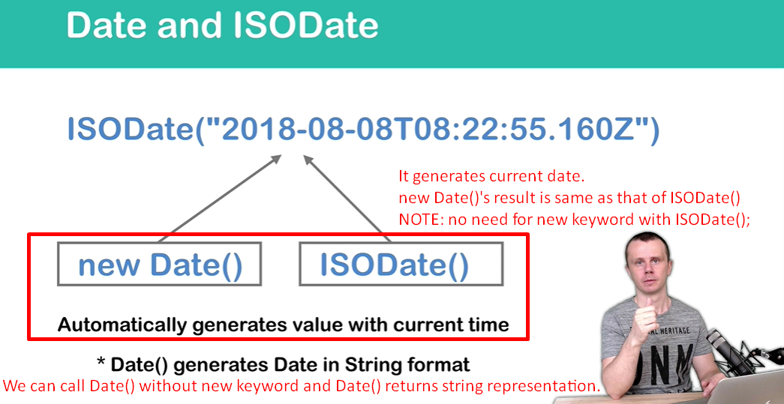
4. 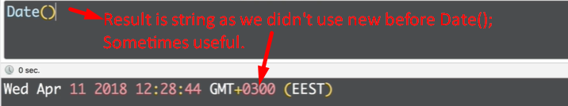
5. 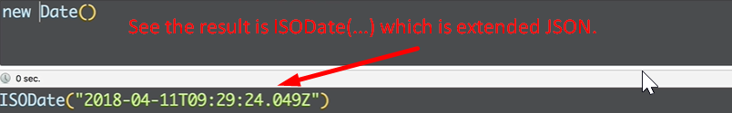
6. 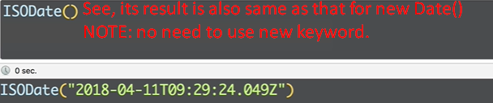
7. 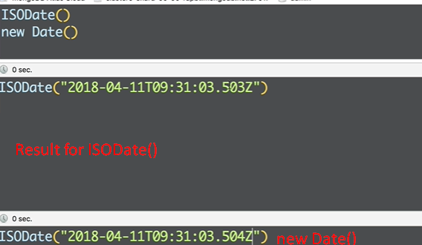
8. 